Swaminathan Navinashok 2019115126

Pgm 5.2.1

Write a ‘C’ program to convert the incoming string (character array) to its "Pig Latin" version.

Rules to follow:

* If the string starts with a vowel, the Pig Latin version is the original word with "way" added to the end
* If the string starts with a consonant, or a series of consecutive consonants, the Pig Latin version transfers all consonants up to the first vowel to the end of the word, and adds "ay" to the end.

**Example:**

**flower --- owerflay**

**yellow – ellowyay**

**apple – appleway**

**igloo – iglooway**

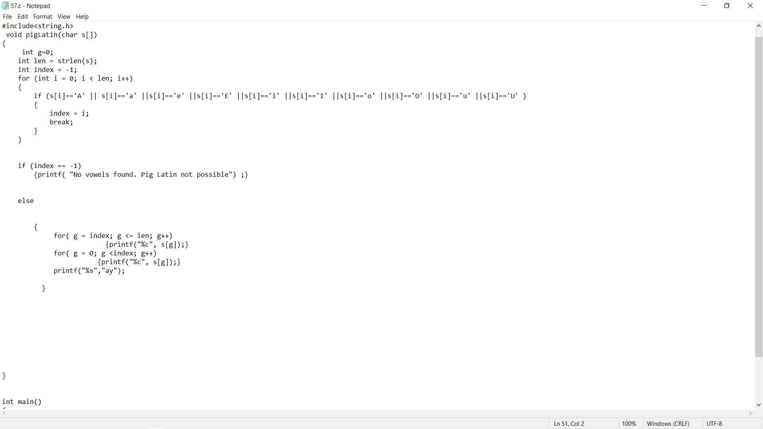

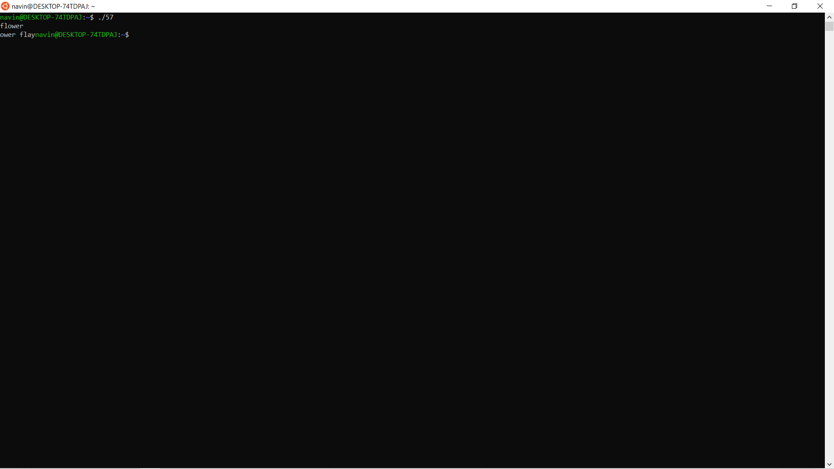**#include <stdio.h>**

**#include<string.h>**

**void pigLatin(char s[])**

**{**

**int g=0;**

**int len = strlen(s);**

**int index = -1;**

**for (int i = 0; i < len; i++)**

**{**

**if (s[i]=='A' || s[i]=='a' ||s[i]=='e' ||s[i]=='E' ||s[i]=='i' ||s[i]=='I' ||s[i]=='o' ||s[i]=='O' ||s[i]=='u' ||s[i]=='U' )**

**{**

**index = i;**

**break;**

**}**

**}**

**if (index == -1)**

**{printf( "No vowels found. Pig Latin not possible") ;}**

**else**

**{**

**for( g = index; g <= len; g++)**

**{printf("%c", s[g]);}**

**for( g = 0; g <index; g++)**

**{printf("%c", s[g]);}**

**printf("%s","ay");**

**}**

**}**

**int main()**

**{**

**char str[100] ;**

**scanf("%s",str);**

**pigLatin(str);**

**return 0;**

**}**